**Unlocking Insights Into The Global Air Transportation Network With Tableau**

**1 INTRODUCTION**

Unlocking insights into the global air transportation network with Tableau involves using Tableau, a powerful data visualization and business intelligence tool, to analyze and present data related to the global air transportation system. This process allows organizations and individuals to gain a deeper understanding of various aspects of air travel, including routes, airports, passengers trends, and more.

**1.1 OVERVIEW**

Analyzing the global air transportation network with Tableau can provide valuable insights. You can create visualizations that show key metrics like traffic volume, busiest airports, airline routes, and more. This can help stakeholders in the aviation industry, policymakers, and researchers understand trends, optimize routes, and plan for future growth.

**1.2 PURPOSE**

Tableau allows for the creation of interactive and visually engaging dashboards, making it easier to comprehend complex data related to airports, routes, passenger volumes, and more .Airlines and airports can use Tableau to analyze the performance of various routes, identifying profitability and areas needing improvement.

**2 PROBLEM DEFINITION & DESIGN THINKING**

**2.1 EMPATHY MAP**

￼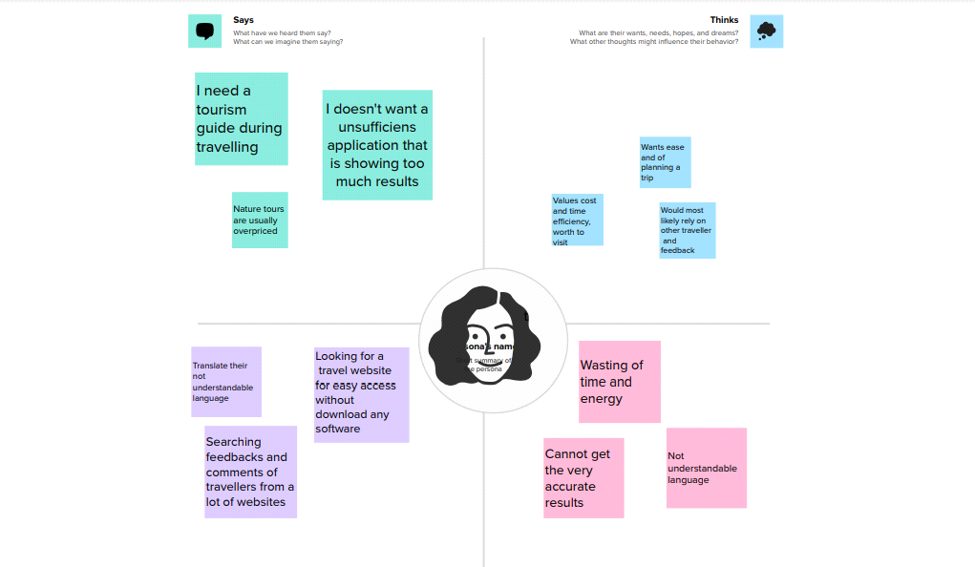

**2.2 IDEATION & BRAINSTTORMING MAP**

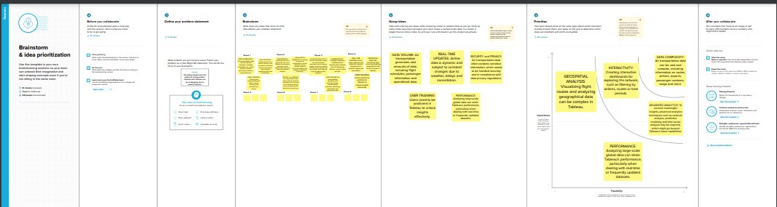

￼

**3 RESULT**

￼￼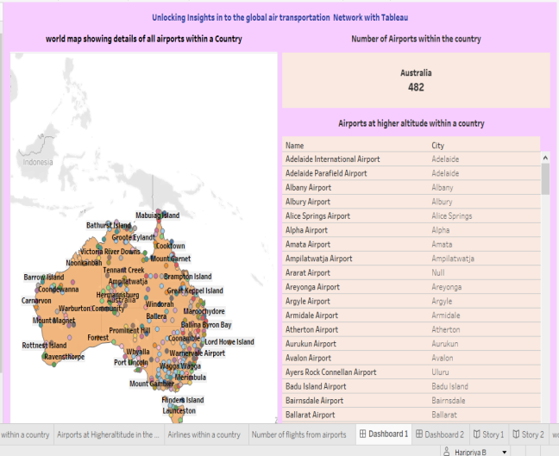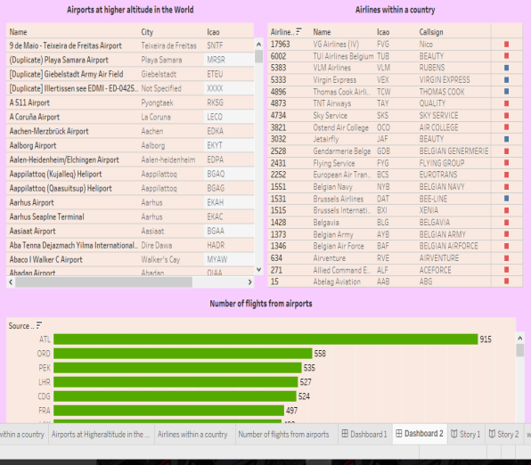

￼￼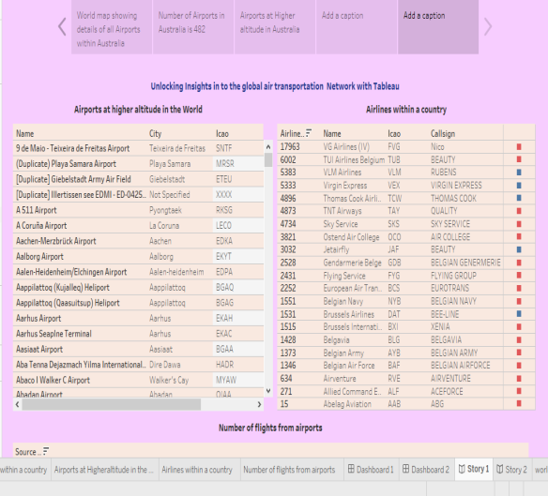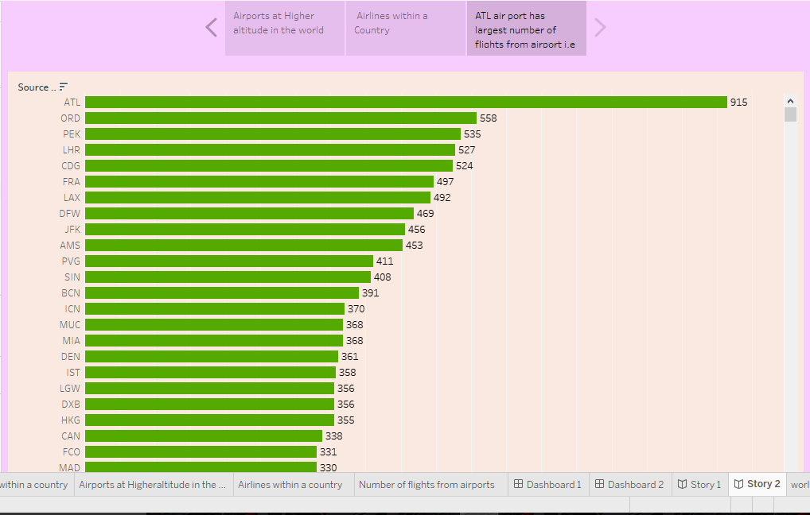

**4 ADVANTAGES& DISADVANTAGES**

ADVANTAGES :

Tableau provides powerful data visualization tools that can transform complex air transportation data into interactive, easy-to-understand visualizations, such as maps, charts, and graphs.

By analyzing historical flight data, airlines can optimize routes, schedules, and resource allocation to improve efficiency and reduce costs.

Analyzing safety and security data can help enhance passenger safety and prevent security breaches.

DISADVANTAGES

Air transportation data is vast and complex, which can make it challenging to model and visualize effectively in Tableau.

Tableau licenses and maintenance can be expensive, especially for large-scale, enterprise-level deployments.

Tableau's insights are only as good as the data it receives. Inaccurate or incomplete data can lead to misleading insights.

**5 APPLICATIONS**

Tableau can help forecast passenger demand on specific routes, enabling airlines to adjust pricing and capacity according.

Safety departments can use Tableau to track safety incidents, analyze trends, and implement measures to enhance aviation safety.

Analyzing data on fuel consumption, emissions, and flight routes can help aviation companies asses and reduce their environmental impact.

Airports can use Tableau to plan infrastructure upgrades based on passenger traffic data and growth predictions.

**6 CONCLUSION**

In conclusion, unlocking insights into the global air transportation network with Tableau offers a powerful set of tools for the aviation industry. However, it's essential to acknowledge the potential challenges, such as data complexity, performance issues, and regulatory compliance, and address them effectively to fully realize the benefits of using Tableau in this industry. Overall, Tableau provides a valuable resource for improving efficiency, sustainability and resilience of the aviation industry.